Pentagonal Pyramid
# Source: AI Source: Provided by: [Data Path: Persons Table -> ID Column: 1, Name_En Column: Motasem Essam] -> From: [ChatGPT] on [7/25/2026]
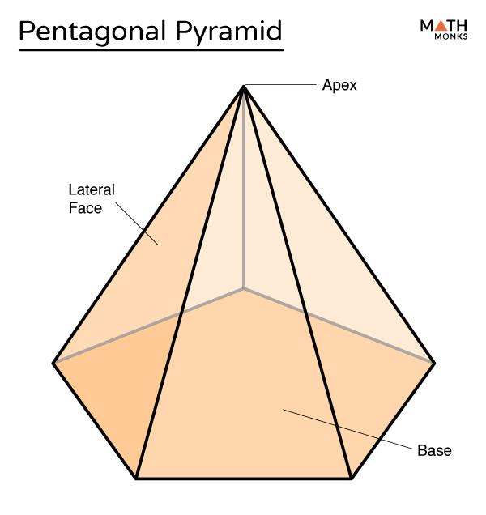
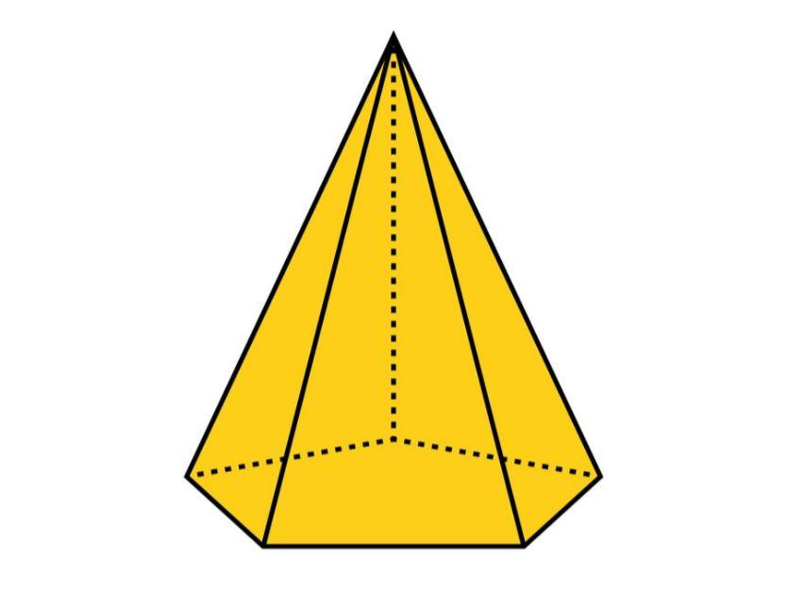
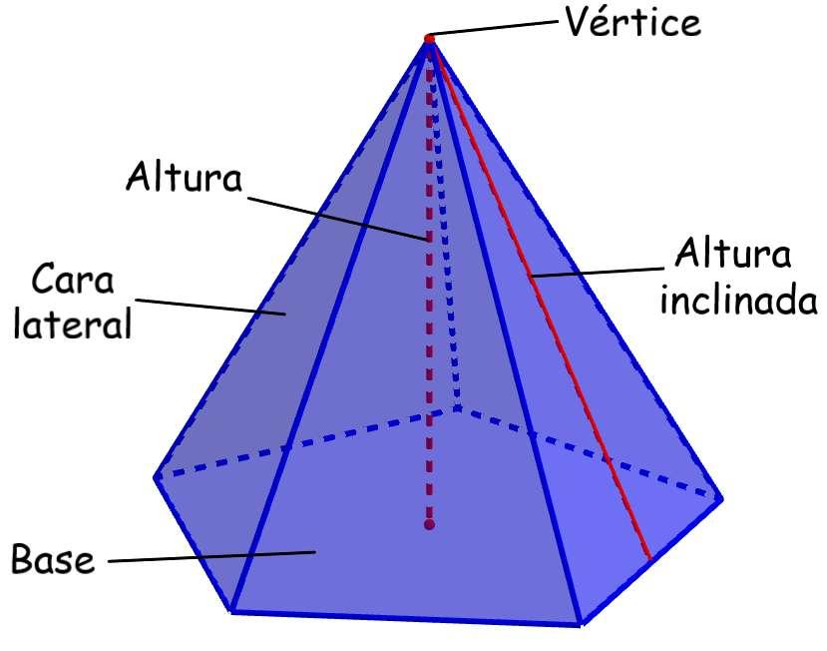

Definition
# Source: AI Source: Provided by: [Data Path: Persons Table -> ID Column: 1, Name_En Column: Motasem Essam] -> From: [ChatGPT] on [7/25/2026]
A pentagonal pyramid is a three-dimensional polyhedron with one pentagonal base and five triangular lateral faces that meet at a common vertex called the apex.
The base is a polygon with five sides and five vertices. A pentagonal pyramid has 6 faces, 10 edges, and 6 vertices.
A pentagonal pyramid may have a regular or irregular pentagonal base. If its base is a regular pentagon and its apex is directly above the base's center, with equal lateral edges, it is a regular pentagonal pyramid.

Simple Definition
# Source: AI Source: Provided by: [Data Path: Persons Table -> ID Column: 1, Name_En Column: Motasem Essam] -> From: [ChatGPT] on [7/25/2026]
A pentagonal pyramid is a solid that has:
- One five-sided polygon as its base.
- Five triangular side faces.
- One apex where the five side faces meet.
- Six faces, ten edges, and six vertices in total.
Unlike a pentagonal prism, which has two parallel pentagonal bases, a pentagonal pyramid has one base and tapers to a single apex.

Classification Tree
# Source: AI Source: Provided by: [Data Path: Persons Table -> ID Column: 1, Name_En Column: Motasem Essam] -> From: [ChatGPT] on [7/25/2026]
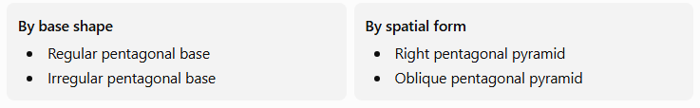
By base shape
- Regular pentagonal base
- Irregular pentagonal base
By spatial form
- Right pentagonal pyramid
- Oblique pentagonal pyramid
These classifications describe different properties. For example, a pentagonal pyramid with a regular pentagonal base can still be oblique if its apex is not directly above the base's center.

Key Characteristics
# Source: AI Source: Provided by: [Data Path: Persons Table -> ID Column: 1, Name_En Column: Motasem Essam] -> From: [ChatGPT] on [7/25/2026]
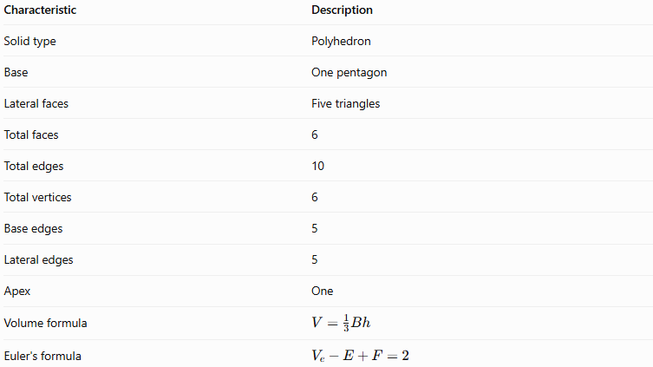
Characteristic | Description
Solid type | Polyhedron
Base | One pentagon
Lateral faces | Five triangles
Total faces | 6
Total edges | 10
Total vertices | 6
Base edges | 5
Lateral edges | 5
Apex | One
Volume formula | $$V=\frac{1}{3}Bh$$
Euler's formula | $$V_{e}-E+F=2$$
Here, $V_{e}$ represents the number of vertices, while $V$ represents volume.

Geometric Representation
# Source: AI Source: Provided by: [Data Path: Persons Table -> ID Column: 1, Name_En Column: Motasem Essam] -> From: [ChatGPT] on [7/25/2026]
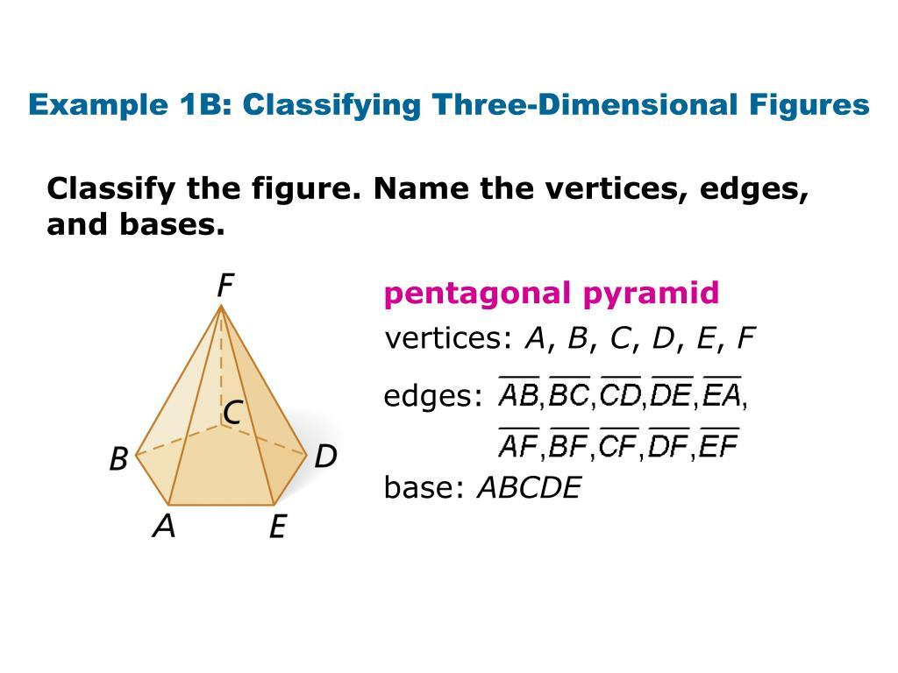
Consider a pentagonal pyramid with base vertices $A,B,C,D,E$ and apex $F$.
Its components are:
- Base face $ABCDE$: The five-sided polygon at the bottom.
- Lateral faces: Five triangles connecting the sides of the pentagonal base to apex $F$.
- Apex $F$: The vertex opposite the base.
- Base edges: $AB,BC,CD,DE,EA$.
- Lateral edges: $AF,BF,CF,DF,EF$.
The five triangular lateral faces meet at the apex, and the pentagon forms the single base.

Mathematical Properties and Formulas
# Source: AI Source: Provided by: [Data Path: Persons Table -> ID Column: 1, Name_En Column: Motasem Essam] -> From: [ChatGPT] on [7/25/2026]
Let:
- $B$ = area of the pentagonal base
- $p$ = perimeter of the base
- $h$ = perpendicular height of the pyramid
- $l$ = slant height of a lateral face, when applicable
- $A_{L}$ = lateral surface area
- $A_{T}$ = total surface area
- $V$ = volume

Number of faces, edges, and vertices
# Source: AI Source: Provided by: [Data Path: Persons Table -> ID Column: 1, Name_En Column: Motasem Essam] -> From: [ChatGPT] on [7/25/2026]
For a pyramid with an $n$-sided base:
$$F=n+1, E=2n, V_{e}=n+1$$
For a pentagonal pyramid, $n=5$:
$$F=5+1=\boxed{6}$$
$$E=2\left(5\right)=\boxed{10}$$
$$V_{e}=5+1=\boxed{6}$$

Area of the pentagonal base
# Source: AI Source: Provided by: [Data Path: Persons Table -> ID Column: 1, Name_En Column: Motasem Essam] -> From: [ChatGPT] on [7/25/2026]
For a regular pentagon with side length $a$:
$$\boxed{B=\frac{1}{4}\sqrt{5\left(5+2\sqrt{5}\right)} a^{2}}$$
An equivalent formula uses the base perimeter $p$ and apothem $r$:
$$\boxed{B=\frac{1}{2}pr}$$
The apothem is the perpendicular distance from the center of a regular polygon to one of its sides.
For an irregular pentagon, the base area can be calculated by dividing the pentagon into triangles or other familiar shapes and adding their areas.

Volume
# Source: AI Source: Provided by: [Data Path: Persons Table -> ID Column: 1, Name_En Column: Motasem Essam] -> From: [ChatGPT] on [7/25/2026]
The volume of any pyramid is one-third of its base area multiplied by its perpendicular height:
$$\boxed{V=\frac{1}{3}Bh}$$
For a regular pentagonal base:
$$V=\frac{h}{12}\sqrt{5\left(5+2\sqrt{5}\right)} a^{2}$$
The height $h$ is measured perpendicular to the base plane, not along a sloping edge.

Lateral surface area
# Source: AI Source: Provided by: [Data Path: Persons Table -> ID Column: 1, Name_En Column: Motasem Essam] -> From: [ChatGPT] on [7/25/2026]
The lateral surface area is the sum of the five triangular lateral faces:
$$\boxed{A_{L}=A_{1}+A_{2}+A_{3}+A_{4}+A_{5}}$$
For a regular pentagonal pyramid, all five lateral faces are congruent isosceles triangles. If $l$ is the slant height:
$$\boxed{A_{L}=\frac{1}{2}pl}$$
Because the base is regular, its perimeter is $p=5a$, giving:
$$\boxed{A_{L}=\frac{5}{2}al}$$
This shortcut applies to a regular pentagonal pyramid, not to every pentagonal pyramid.

Total surface area
# Source: AI Source: Provided by: [Data Path: Persons Table -> ID Column: 1, Name_En Column: Motasem Essam] -> From: [ChatGPT] on [7/25/2026]
The total surface area includes the pentagonal base and all five triangular lateral faces:
$$\boxed{A_{T}=B+A_{L}}$$
For a regular pentagonal pyramid:
$$\boxed{A_{T}=B+\frac{12}{p}l}$$

Euler's formula
# Source: AI Source: Provided by: [Data Path: Persons Table -> ID Column: 1, Name_En Column: Motasem Essam] -> From: [ChatGPT] on [7/25/2026]
For a convex pentagonal pyramid:
$$V_{e}-E+F=2$$
Substituting the counts:
$$6-10+6=\boxed{2}$$
Therefore, the pentagonal pyramid satisfies Euler's formula.

Types of Pentagonal Pyramids

Regular Pentagonal Pyramid
# Source: AI Source: Provided by: [Data Path: Persons Table -> ID Column: 1, Name_En Column: Motasem Essam] -> From: [ChatGPT] on [7/25/2026]
Has a regular pentagonal base and an apex directly above its center. Its five lateral faces are congruent isosceles triangles, and its lateral edges are equal in length.
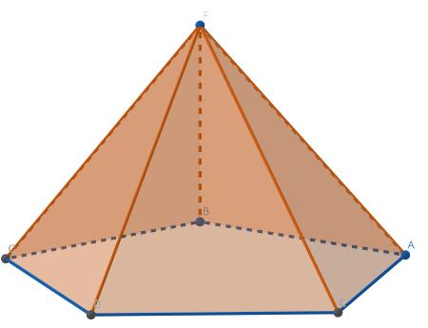

Irregular Pentagonal Pyramid
# Source: AI Source: Provided by: [Data Path: Persons Table -> ID Column: 1, Name_En Column: Motasem Essam] -> From: [ChatGPT] on [7/25/2026]
Has an irregular pentagonal base, or otherwise does not have the symmetry required of a regular pentagonal pyramid. Its lateral faces need not be congruent.
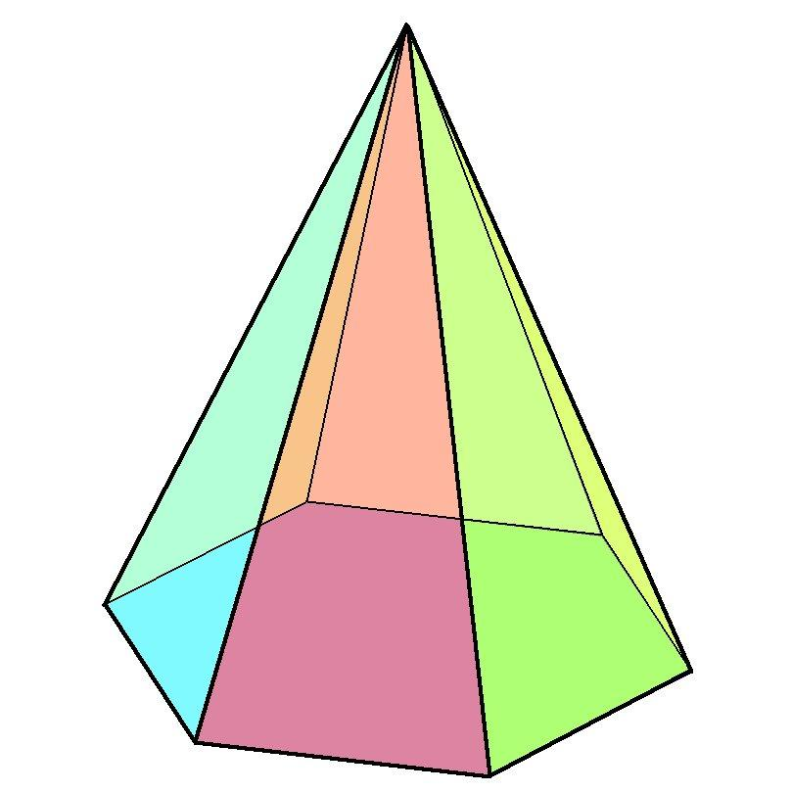

Right Pentagonal Pyramid
# Source: AI Source: Provided by: [Data Path: Persons Table -> ID Column: 1, Name_En Column: Motasem Essam] -> From: [ChatGPT] on [7/25/2026]
The perpendicular from the apex meets the base at its center. Its base may be regular or irregular.
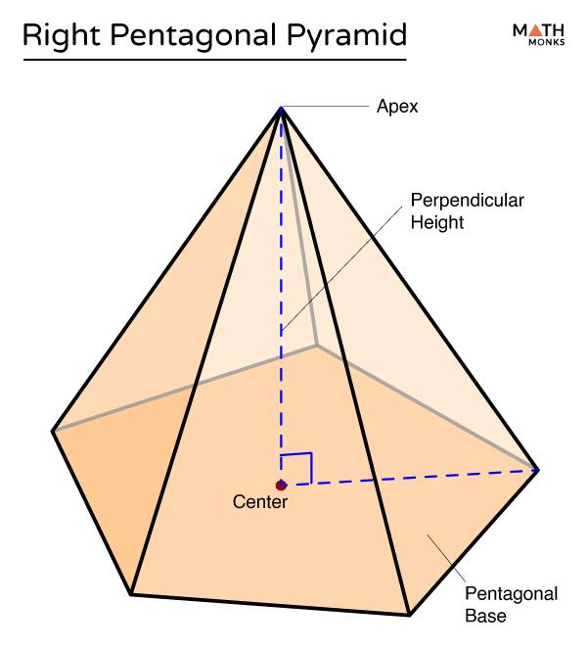

Oblique Pentagonal Pyramid
# Source: AI Source: Provided by: [Data Path: Persons Table -> ID Column: 1, Name_En Column: Motasem Essam] -> From: [ChatGPT] on [7/25/2026]
The apex is not directly above the center of the base, so the pyramid leans to one side.
Important distinction: Regular describes the symmetry of the pyramid, including its regular base and congruent lateral faces. Right describes the position of the apex relative to the base. These terms describe different properties.
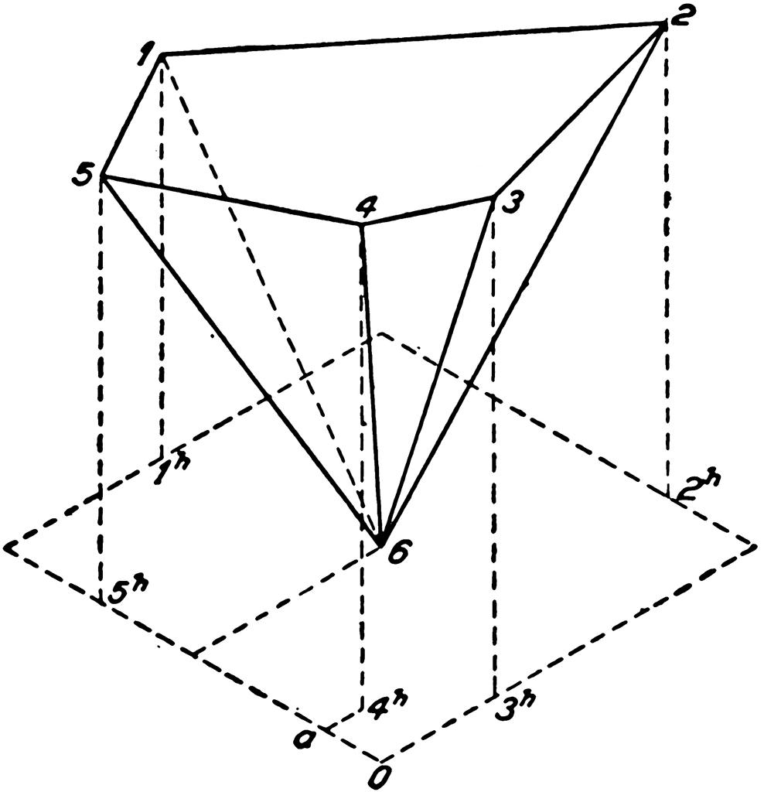

Worked Examples
# Source: AI Source: Provided by: [Data Path: Persons Table -> ID Column: 1, Name_En Column: Motasem Essam] -> From: [ChatGPT] on [7/25/2026]
Example 1: Counting faces, edges, and vertices
Problem: Find the number of faces, edges, and vertices of a pentagonal pyramid.
Solution:
- Faces: $5+1=\boxed{6}$
- Edges: $2\left(5\right)=\boxed{10}$
- Vertices: $5+1=\boxed{6}$
Answer: 6 faces, 10 edges, and 6 vertices.
Example 2: Calculating volume
Problem: A pentagonal pyramid has a base area of $50{\text{ cm}}^{2}$ and a perpendicular height of $12\text{ cm}$. Find its volume.
Solution:
$$V=\frac{13}{B}h$$
$$V=\frac{13}{\left(50\right)}\left(12\right)$$
$$\boxed{V=200{\text{ cm}}^{3}}$$
Answer: The volume is $200{\text{ cm}}^{3}$.
Example 3: Calculating the base area of a regular pentagon
Problem: A regular pentagonal pyramid has a base side length of $4\text{ cm}$. Find the base area.
Solution:
Use the regular pentagon formula:
$$B=\frac{14}{\sqrt{5\left(5+2\sqrt{5}\right)}} a^{2}$$
Substitute $a=4$:
$$B=\frac{14}{\sqrt{5\left(5+2\sqrt{5}\right)}}\left(16\right)$$
$$B=4\sqrt{5\left(5+2\sqrt{5}\right)}$$
$$\boxed{B≈27.53{\text{ cm}}^{2}}$$
Answer: The base area is approximately $27.53{\text{ cm}}^{2}$.
Example 4: Calculating lateral surface area
Problem: A regular pentagonal pyramid has a base side length of $6\text{ cm}$ and a slant height of $8\text{ cm}$. Find its lateral surface area.
Solution:
First, calculate the perimeter:
$$p=5\left(6\right)=30\text{ cm}$$
Then use the regular pyramid formula:
$$A_{L}=\frac{12}{p}l$$
$$A_{L}=\frac{12}{\left(30\right)}\left(8\right)$$
$$\boxed{A_{L}=120{\text{ cm}}^{2}}$$
Answer: The lateral surface area is $120{\text{ cm}}^{2}$.
Example 5: Verifying Euler's formula
Problem: Verify Euler's formula for a pentagonal pyramid.
Solution:
$$V_{e}-E+F=6-10+6$$
$$\boxed{2=2}$$
Answer: Euler's formula is satisfied.

Pentagonal Pyramid vs. Pentagonal Prism
# Source: AI Source: Provided by: [Data Path: Persons Table -> ID Column: 1, Name_En Column: Motasem Essam] -> From: [ChatGPT] on [7/25/2026]

Pentagonal Pyramid
- One pentagonal base.
- One apex.
- 6 faces.
- 10 edges.
- 6 vertices.
- $V=\frac{1}{3}Bh$.
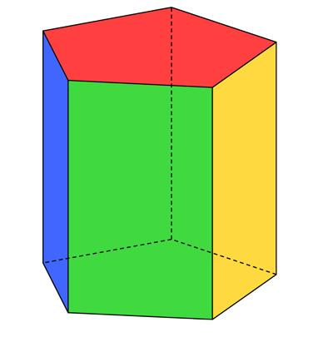
Pentagonal Prism
- Two congruent parallel pentagonal bases.
- No single apex.
- 7 faces.
- 15 edges.
- 10 vertices.
- $V=Bh$.
The main difference is that a pentagonal pyramid has one base and tapers to an apex, whereas a pentagonal prism has two congruent, parallel pentagonal bases.

Constructing Pentagonal Pyramid in Solid Geometry

Instruments Used
# Source: AI Source: Provided by: [Data Path: Persons Table -> ID Column: 1, Name_En Column: Motasem Essam] -> From: [ChatGPT] on [7/25/2026]
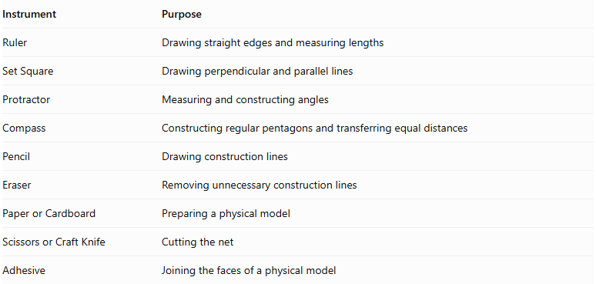
Instrument | Purpose
Ruler | Drawing straight edges and measuring lengths
Set Square | Drawing perpendicular and parallel lines
Protractor | Measuring and constructing angles
Compass | Constructing regular pentagons and transferring equal distances
Pencil | Drawing construction lines
Eraser | Removing unnecessary construction lines
Paper or Cardboard | Preparing a physical model
Scissors or Craft Knife | Cutting the net
Adhesive | Joining the faces of a physical model

Construction Procedures

A. Base-Based Construction
# Source: AI Source: Provided by: [Data Path: Persons Table -> ID Column: 1, Name_En Column: Motasem Essam] -> From: [ChatGPT] on [7/25/2026]
- Construct a pentagonal base using a ruler, compass, and protractor.
- Determine the required position of the apex.
- Mark the apex above or away from the base.
- Connect the apex to the five vertices of the pentagonal base.
- Complete the five triangular lateral faces.
- Verify that all edges are properly connected.
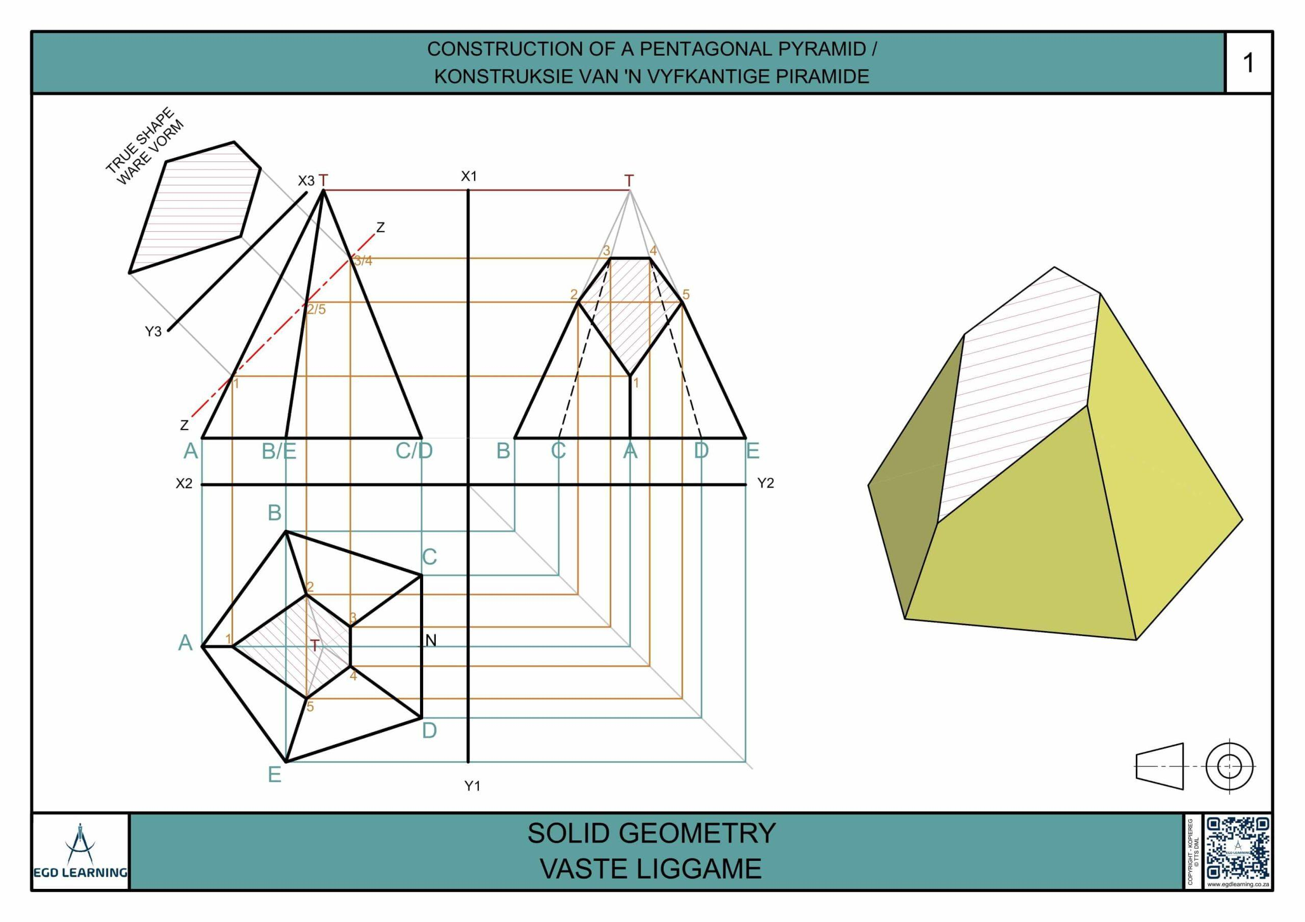

B. Apex-Based Construction
# Source: AI Source: Provided by: [Data Path: Persons Table -> ID Column: 1, Name_En Column: Motasem Essam] -> From: [ChatGPT] on [7/25/2026]
- Mark a point representing the apex.
- Construct five base vertices at the required positions.
- Connect the five base vertices to form a pentagon.
- Connect the apex to each of the five base vertices.
- Complete the six faces of the pyramid.

C. Vertex-Connection Construction
# Source: AI Source: Provided by: [Data Path: Persons Table -> ID Column: 1, Name_En Column: Motasem Essam] -> From: [ChatGPT] on [7/25/2026]
- Identify the five vertices of the pentagonal base.
- Identify the apex.
- Connect the apex to each of the five base vertices.
- Verify that five lateral edges are formed.
- Confirm that the solid has six vertices in total.

D. Edge-Based Construction
# Source: AI Source: Provided by: [Data Path: Persons Table -> ID Column: 1, Name_En Column: Motasem Essam] -> From: [ChatGPT] on [7/25/2026]
- Construct the five edges of the pentagonal base.
- Determine the lengths of the five lateral edges.
- Construct the lateral edges from the base vertices toward the apex.
- Join their upper endpoints at the common apex.
- Complete the five triangular lateral faces.

E. Face-Based Construction
# Source: AI Source: Provided by: [Data Path: Persons Table -> ID Column: 1, Name_En Column: Motasem Essam] -> From: [ChatGPT] on [7/25/2026]
- Construct the pentagonal base.
- Construct the five triangular lateral faces.
- Connect each lateral face to its corresponding base edge.
- Join the lateral faces along their common lateral edges.
- Verify that the resulting solid is closed.

F. Net-Based Construction
# Source: AI Source: Provided by: [Data Path: Persons Table -> ID Column: 1, Name_En Column: Motasem Essam] -> From: [ChatGPT] on [7/25/2026]
The net of a pentagonal pyramid consists of:
- One pentagonal base.
- Five triangular lateral faces.
- Optional tabs for joining the faces.
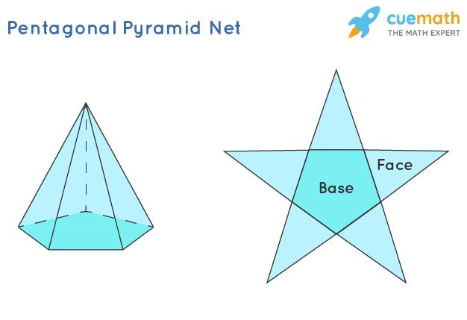

G. Physical Model Construction
# Source: AI Source: Provided by: [Data Path: Persons Table -> ID Column: 1, Name_En Column: Motasem Essam] -> From: [ChatGPT] on [7/25/2026]
- Draw the complete net on cardboard.
- Include joining tabs around selected edges.
- Cut out the net.
- Fold along the boundaries of the six faces.
- Join the five triangular lateral faces together.
- Attach the pentagonal base.
- Secure the edges using adhesive.

Real-World Applications
# Source: AI Source: Provided by: [Data Path: Persons Table -> ID Column: 1, Name_En Column: Motasem Essam] -> From: [ChatGPT] on [7/25/2026]
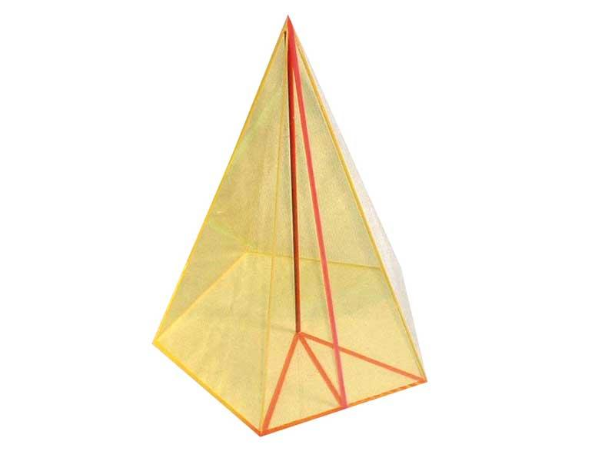
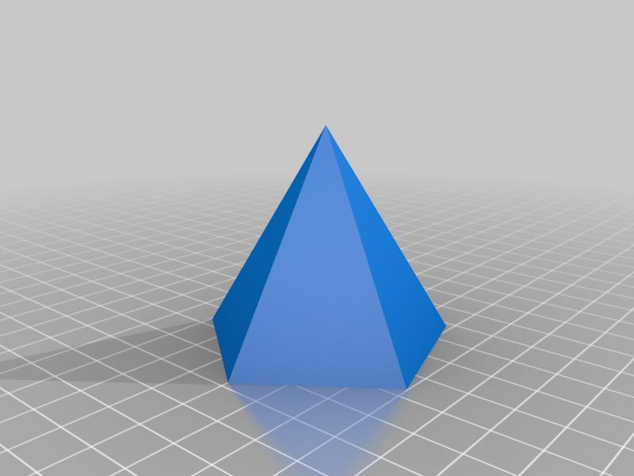
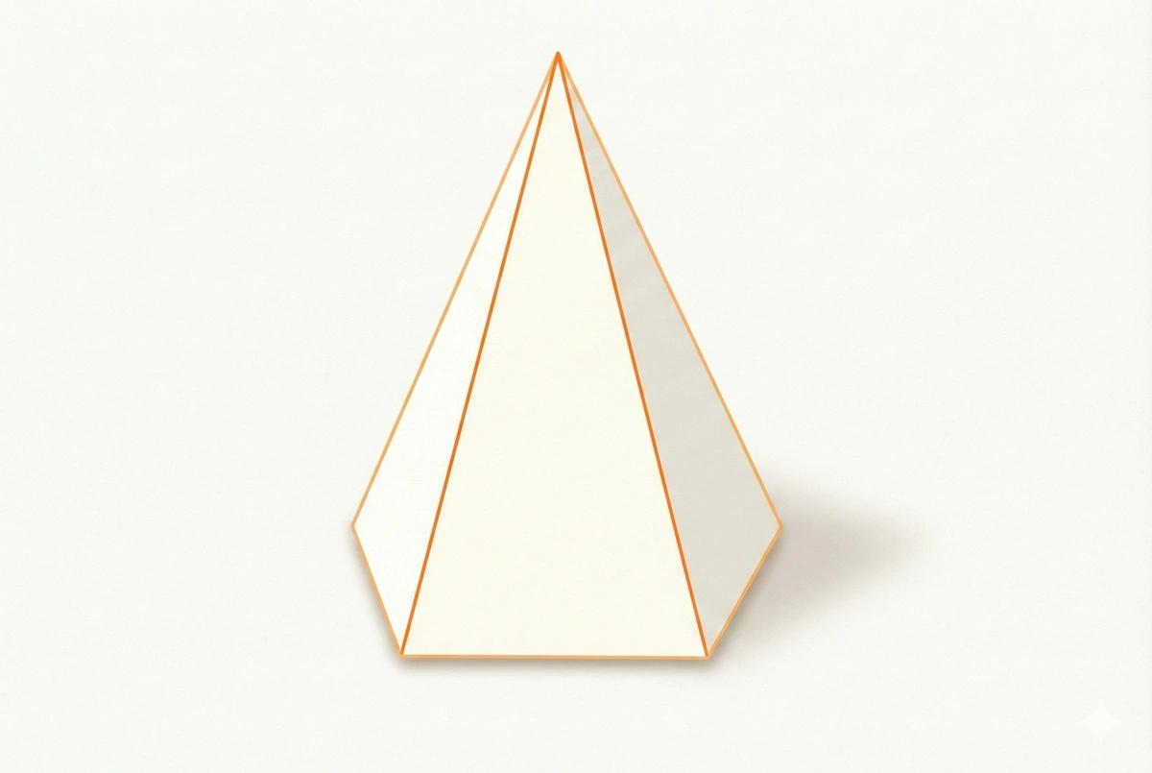
Pentagonal pyramids are useful in:
- Architecture: Designing unusual roofs, decorative caps, and sculptural structures.
- Engineering: Modeling tapered components with pentagonal cross-sections.
- Mathematics education: Studying polygonal bases, triangular faces, and polyhedral properties.
- Computer graphics: Constructing polygon-based 3D objects and meshes.
- Geometric design: Creating symmetric or asymmetric pyramid-shaped sculptures and objects.
These are applications of the geometry; real objects may include extra faces or structural details.

Key Points
# Source: AI Source: Provided by: [Data Path: Persons Table -> ID Column: 1, Name_En Column: Motasem Essam] -> From: [ChatGPT] on [7/25/2026]
- A pentagonal pyramid has one pentagonal base and five triangular lateral faces.
- It has 6 faces, 10 edges, and 6 vertices.
- Its volume is $V=\frac{1}{3}Bh$.
- Its total surface area is $A_{T}=B+A_{L}$.
- For a regular pentagonal pyramid, $A_{L}=\frac{1}{2}pl$.
- The perpendicular height and slant height are different measurements.
- A regular pentagonal pyramid has a regular pentagon as its base and congruent lateral faces.
- A convex pentagonal pyramid satisfies Euler's formula: $V_{e}-E+F=2$.

Conclusion
# Source: AI Source: Provided by: [Data Path: Persons Table -> ID Column: 1, Name_En Column: Motasem Essam] -> From: [ChatGPT] on [7/25/2026]
A pentagonal pyramid is a polyhedron with a five-sided base, five triangular lateral faces, and a single apex. It has six faces, ten edges, and six vertices, regardless of whether its base is regular or irregular.
Its volume depends on the base area and perpendicular height, while its surface area depends on the areas of the base and five lateral faces. A regular pentagonal pyramid is a particularly symmetrical case, with a regular pentagonal base and five congruent triangular side faces.

